Colonial Adventure Tour Case

RYNASIA PETTIFORD

Sullivan University

CSC210: Database Design

Tuan Tran

February 11, 2024

**Colonial Adventure Tours Case**

**List the last name of each guide who does not live in New Hampshire (NH).**

**List the trip name of each trip that has the type Paddling.**

**List the trip name of each trip that has the season Late Spring.**

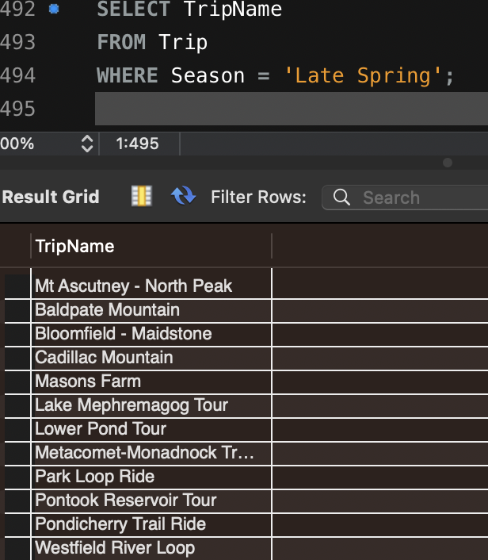

**List the trip name of each trip that has the type Biking and that has a distance longer than 20 miles.**

**List the trip name of each trip that is in the state of Vermont (VT) or that has a maximum group size greater than 10.** 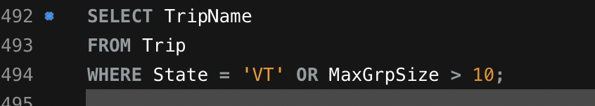

**List the trip name of each trip that has the season Early Fall or Late Fall.**

**How many trips are in the states of Vermont (VT) or Connecticut (CT)?**

**List the trip name of each trip that has Miles Abrams as a guide.**

**List the trip name of each trip that has the type Biking and that has Rita Boyers as a guide.**

**For each reservation that has a trip date of July 23, 2018, list the customer’s last name, the trip name, and the start location.**

**How many reservations have a trip price that is greater than $50.00 but less than $100.00?**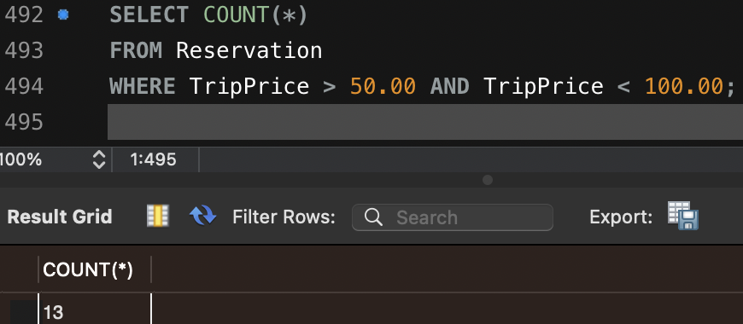

**For each trip that has more than one guide that can lead the trip, list the trip name, the trip type, and the first and last names of each guide.**

**For each customer that has more than one reservation, list the customer’s first and last names, the trip name, and the trip type.** 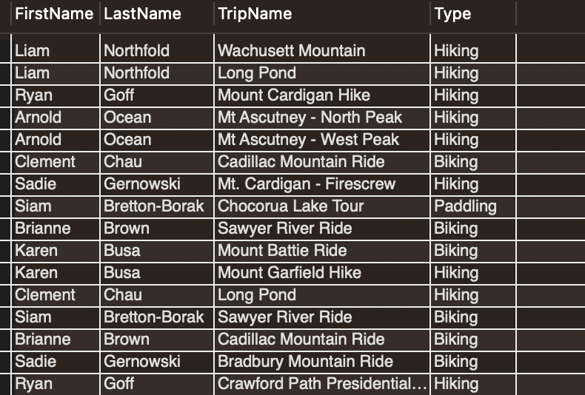

**For each reservation with a trip price of greater than $100.00, list the customer’s last name, the trip name, and the trip type.**

**List the last name of each customer who has a reservation for a trip in Maine (ME).**